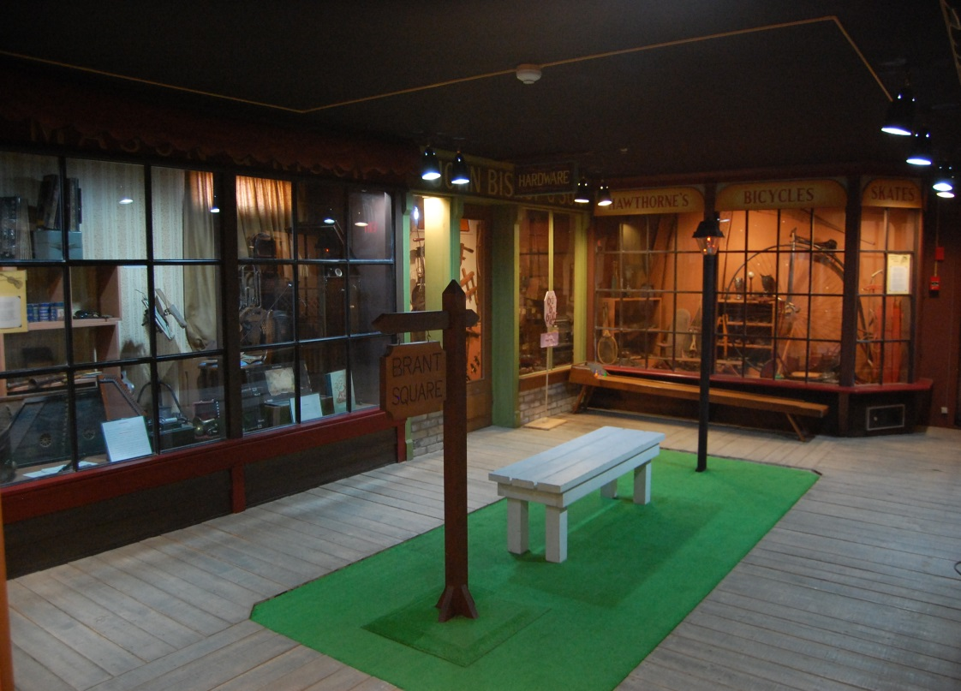 |  | Brant Museum & Archives  57 Charlotte Street  Brantford, Ontario, N3T2W6  519-752-2483  information@brantmuseums.ca  Myrtleville House Museum  34 Myrtleville Drive  Brantford, Ontario, N3V1C2  519-752-3216
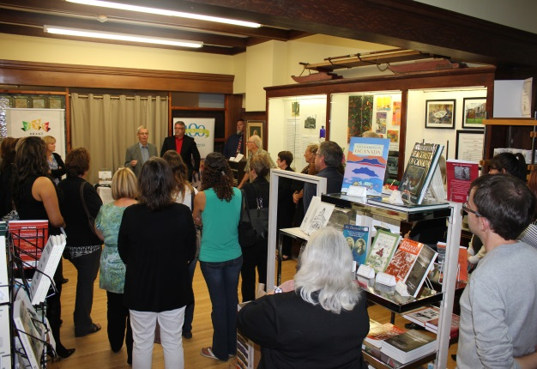

From the Executive Director’s Desk
by Lana Jobe
The summer has gone by and fall is upon us. We have been hard at work re-organizing our programing as well as the Museum and Archives. Our Antiques Appraisal Day and heritage workshop is just one of the new programs being presented to the community. High Tea, and lectures on pottery, blacksmithing, flint napping, 1812 weaponry, and a traditional drum maker delighted and entertained visitors throughout the day. We hope to develop this event into a day that will include the many County Heritage groups so they will be able to promote their sites as well. The Brant Museums and Galleries Association is also planning information booths to promote our BMGA in the Lynden Park Mall. This event will take place Saturday, February 17, 2015.
Our Inventory project has been in the spotlight for the past year and is going well. To assist us with this endeavor, The Canadian Conservation Institute has chosen BHS for their RE:ORG project in March. This is a pilot project for the whole of Canada. Currently they are launching this project in Ontario. Six sites in Ontario have been chosen to participate in the project besides ourselves. The primary idea is to make space in buildings that are bursting at the seams with treasures, and to help save historic buildings instead of building new facilities. As hosts we will be allowed to make special applications to the Museum Assistance Program to help us with the cost of shelving and packing material. For the first three days teams will work on building shelving and wrapping and packing artifacts. The fourth day is a conference type workshop to present the previous day’s work to other groups. We will be preparing for the upcoming event for the next few months, and will need a few volunteers to help with woodworking and electrical issues. Please phone the office if you are interested.
We have also applied and received several grants for special projects to be announced in the near future.
Our hardworking staff also presented a gala opening for the Family Counselling Centre to celebrate their hundredth anniversary. The Display will be up until December 31. The following display in the new year will be based on Natural and Native History of the Grand River.
We hope to see everyone here as they enjoy these informative displays.

Lana

.

Speaker Series
Wednesday, November 19th: Members of the GWCA will be presenting on 100th anniversary of WWI.

Wednesday, December 17th: Join us on our volunteer appreciation night at Myrtleville House Museum
*Speaker Series are free for members with membership card, $10 for non-members. Doors open at 7PM.
Walking Tours
Saturday, November 1st at 10:30 AM
"The Fording Place and the War of 1812" Walk
The walk begins at the parking lot of D'Aubigny Creek Park in West Brantford.

Saturday November 8th at 10:30 AM
"Monuments & Memorials" Walk
This is a good complement to Remembrance Day activities. The walk begins at Jubilee Terrace (Armouries) next to Lorne Bridge.

*Walking Tours are free for members with membership card, $5 for non-members.

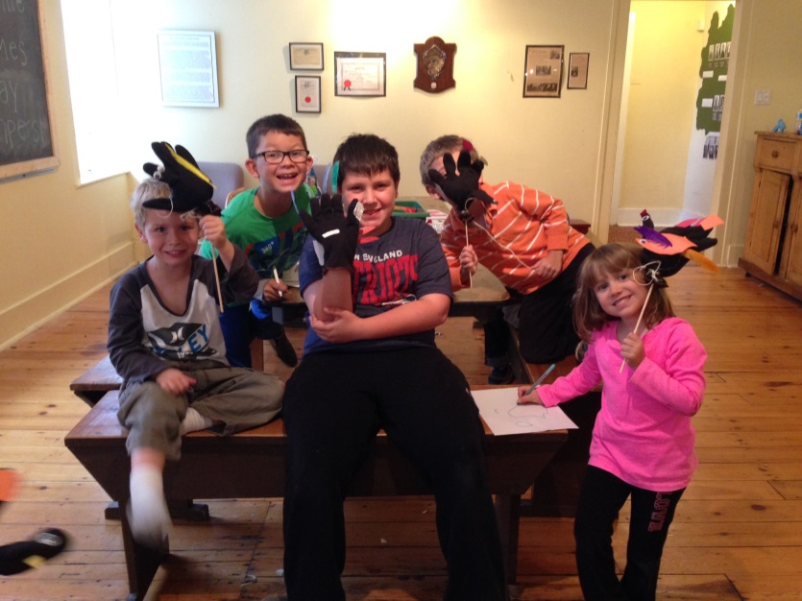
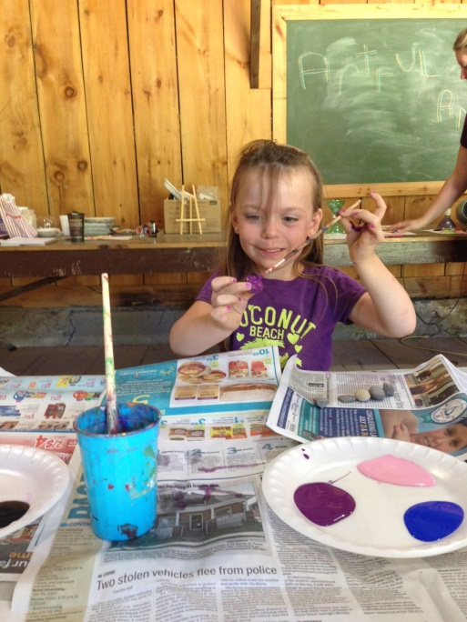

Myrtleville House Museum
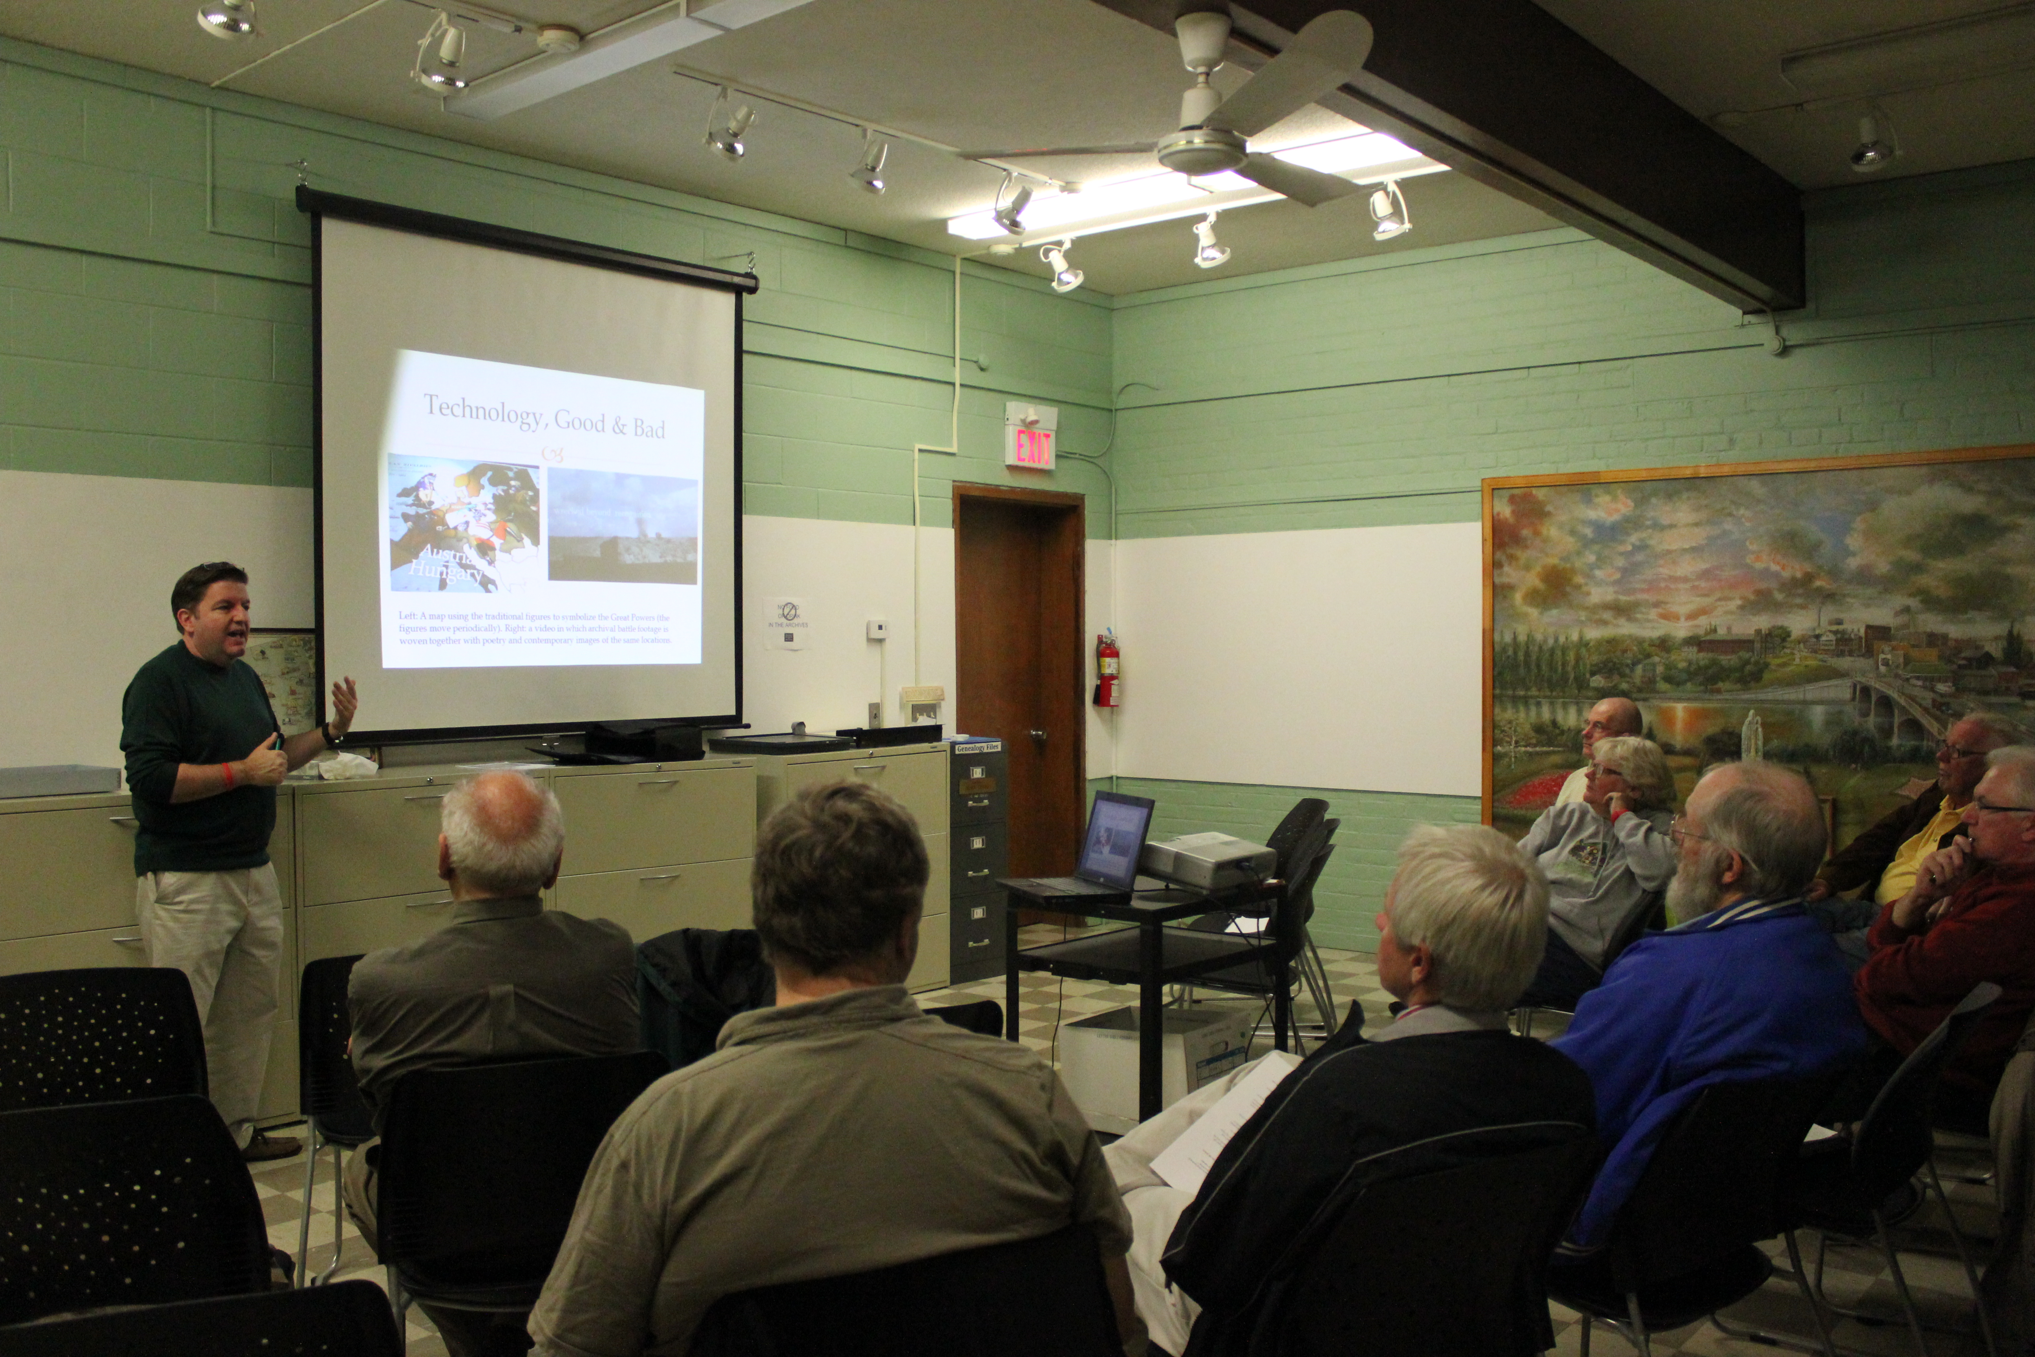
The Two Faces of War
Dr. Peter Farrugia, a professor from Wilfrid Laurier University who specializes in History & Society, Culture and the Environment, was the speaker at our Monthly Speaker’s Series in October. After a request from attendees, we decided to move to Wednesday night for the rest of the year in hopes that more participants could attend.
Peter shared a story of his experience visiting two different museums, the Imperial War Museum (IWM), located in London, England and the Historial de la Grande Guerre (HGG) in Péronne, France. The IWM is tasked with all wars that the United Kingdom has participated in since WWI and the museum in Péronne features only artefacts from WWI from all over Europe, traditionally an example from each Britain, France, and Germany.
The IWM is an open space museum showing rockets, planes, cannons and tanks with interactive exhibits allowing people to dress up in a soldier’s uniform. Farrugia described the museum as offering an experience, creating a walkthrough of a trench with silhouettes of soldiers projected throughout. He added that is seemed as you approached the wall of the trench you could hear quiet conversations of the soldiers in the background. Farrugia also highlighted how they incorporate technology into the museum in both good and bad ways.
The HGG on the other hand was a more traditional museum located in the field of the Battle of the Somme. This museum took a different approach by focusing on historians and museum technicians in the creation of the exhibit space. Farrugia highlighted the horizontality of the exhibit space so that most artefacts are on an equal plane and “positive” artefacts, that highlight beautiful creations in the midst of war, were placed high.
All attendees of the talk were very engaged with the topic and interested in asking a series of follow up questions at the end of the presentation. We are looking forward to next month’s presentation by Chad Martin of the Great War Centenary Association in remembrance of the start of WWI a hundred years ago.

Upcoming Events at Myrtleville House Museum:
Friday, November 14th: P.A Day Camp: Willy Wonka and the Chocolate Factory Theme
Monday December 22nd – Friday January 2nd: Museum closed for Christmas Break
Monday, January 12th: P.A Day Camp: Inventors Workshop
Monday, March 16th- Friday, March 22nd: Heroes Themed March Break Camp
Please contact Sarah Thomas at 519-752-2483, or sarah.thomas@brantmuseums.ca for more information.

Welcome Back Students! The Myrtleville House Museum is happy to open it’s doors to eager young minds this new school year. Myrtleville will continue to be a community partner to Brantford’s school community by providing curriculum based education programs. This fall we are presenting the Harvest Moon Education Program. In this program students will tour the historic house in search of Millie the Mouse and her friends. Bake apple cookies in the historic kitchen, have a tour of the old workshop and have a fun, hands-on experience bringing in the harvest. Students de-shell corn and grind it into corn meal and use our traditional apple cider press. We also welcomed back our campers last Friday for their first PA Day Camp of the year. Campers enjoyed a fun filled day on the farm, and made beautiful decorations for Thanksgiving.

