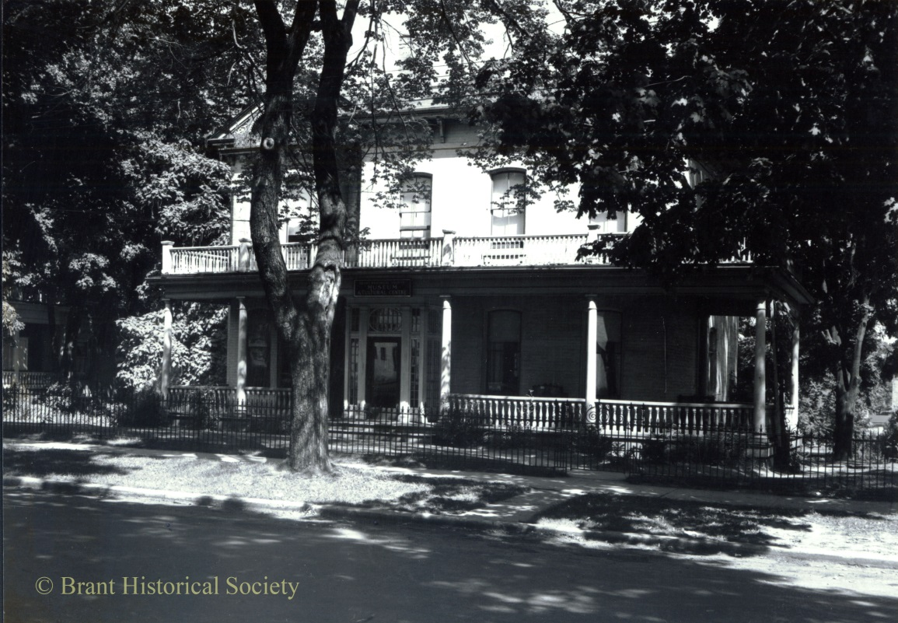 |  | Brant Museum & Archives  57 Charlotte Street  Brantford, Ontario, N3T2W6  519-752-2483  information@brantmuseums.ca  Myrtleville House Museum  34 Myrtleville Drive  Brantford, Ontario, N3V1C2  519-752-3216

With summer upon us, we are experiencing a sharp increase in research requests .We answer questions from far and wide, all concerning our County of Brant. This is the reason we have worked so hard this past year to inventory the Archives. We now have a team of researchers that can source information more easily. The re-organization of the Archives means that documents are now in proper storage and will last years longer for future generations to access.
We have an extensive collection of letters written by WWI soldiers to family and friends. This being the 100th anniversary of WWI, is an ideal time to honour our heroes, by reliving their day-to-day lives during war time.
Our Land Registry books have been in great demand over the past year. There have been numerous requests for Brantford, and South Dumfries family genealogy, and land title searches. Join us at the Museum when our Land Registry books arrive later this month. We look forward to bringing them back for public access without having to make an appointment to view them.
Part of our ongoing effort to encourage professional development for staff includes the museum studies program directed by the Ontario Museum Association. This is a nine course certificate program designed to train staff in collections management, building maintenance, stewardship, marketing, and policies and procedures to name a few. The Staff has toured Woodland Cultural Centre for the “Back Stage” tour guided by Paula Whitlow. Seeing how other sites deal with collections and storage issues gives us an insight in maintaining our own site. Building cultural contacts is also an important part of serving our community.
Speaker Series
July 17: A Sneak Peek at our Online Exhibit, Rachel McNeill & Caleb Bray
August 21: Told Tales Well Spun, the Taletellers Guild
September 18: Modern Museums & Digitization, by Syd Bolton of the Personalized Computer Museum
*Speaker Series are free for members, $10 for non-members
Walking Tours
August 2, 10:30am: "Alexandra Park & East Ward" Walk
The walk begins at the cannon in Alexandra Park (at Colborne and Park).

September 6, 10:30am: "Brantford Canal" Walk
The walk begins at Gore Park (Walk of Fame).

*Walking tours are free for members, $5 for non-members.
Our Staff has been working very hard to put new programming in place, to better use the collection our community has entrusted in our care. Watch for these in the upcoming months, and as always if there are suggestions for new events and opportunities, we welcome your input.
Thanks to a great Staff for their ongoing support during this time of transition.
Lana

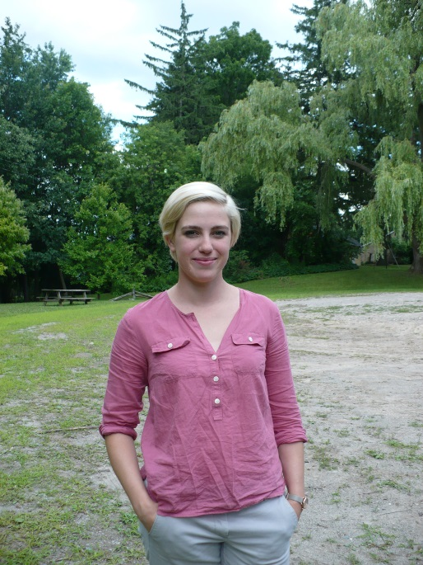
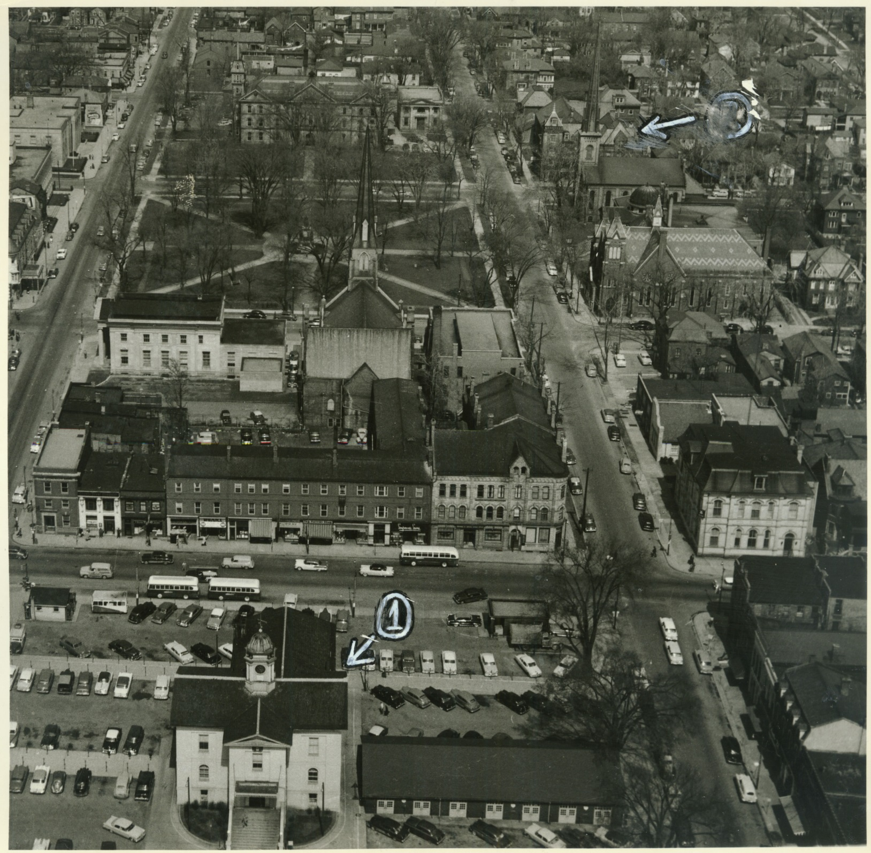

From the Executive Director’s Desk
by Lana Jobe
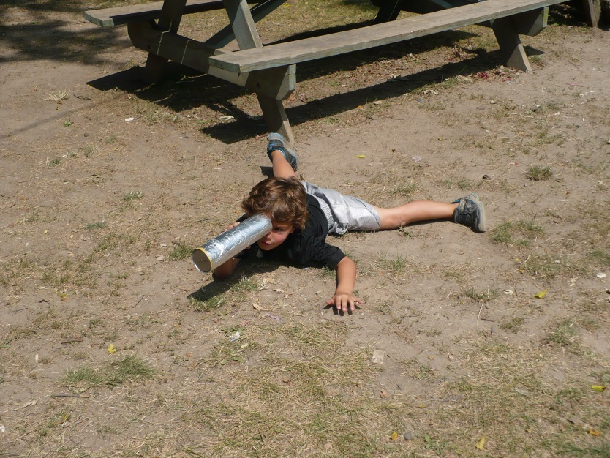
Education Officer, Sarah Thomas
I’m Sarah Thomas and I am so glad to be working with The Brant Historical Society as the Myrtleville House Museum Education Officer! I am not native to Brantford; I grew up in Aurora Ontario, but am happy to have been warmly welcomed by Brantford and its historical community. I have always had a passion for history and pursued a history degree at Saint Mary’s University in Halifax. My studies focused on European history from classical antiquity to the new world. In 2012 I received my Bachelor of Arts with a major in history and minor in psychology. After graduation I returned to Ontario, and moved to Mount Pleasant, were I currently reside.
I was introduced to Myrtleville in December as a volunteer for the Good Cheer Education Program. I was looking to gain some experience teaching and working with children, as I felt that was the avenue I wanted to pursue for a career. I absolutely loved spending time at the museum and participated in nearly every school and camp program I could. It was truly a dream come true to be offered a permanent position working at Myrtleville. I aim to continue to expand our educational programs, fun camp adventures, and welcome our community to share in the wonderful local history Myrtleville has to offer.

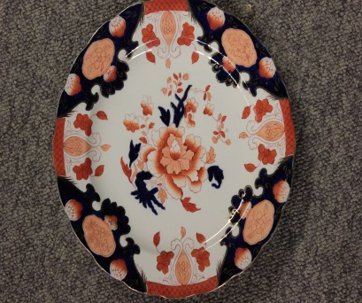
Dishin’ Up Some Oddities
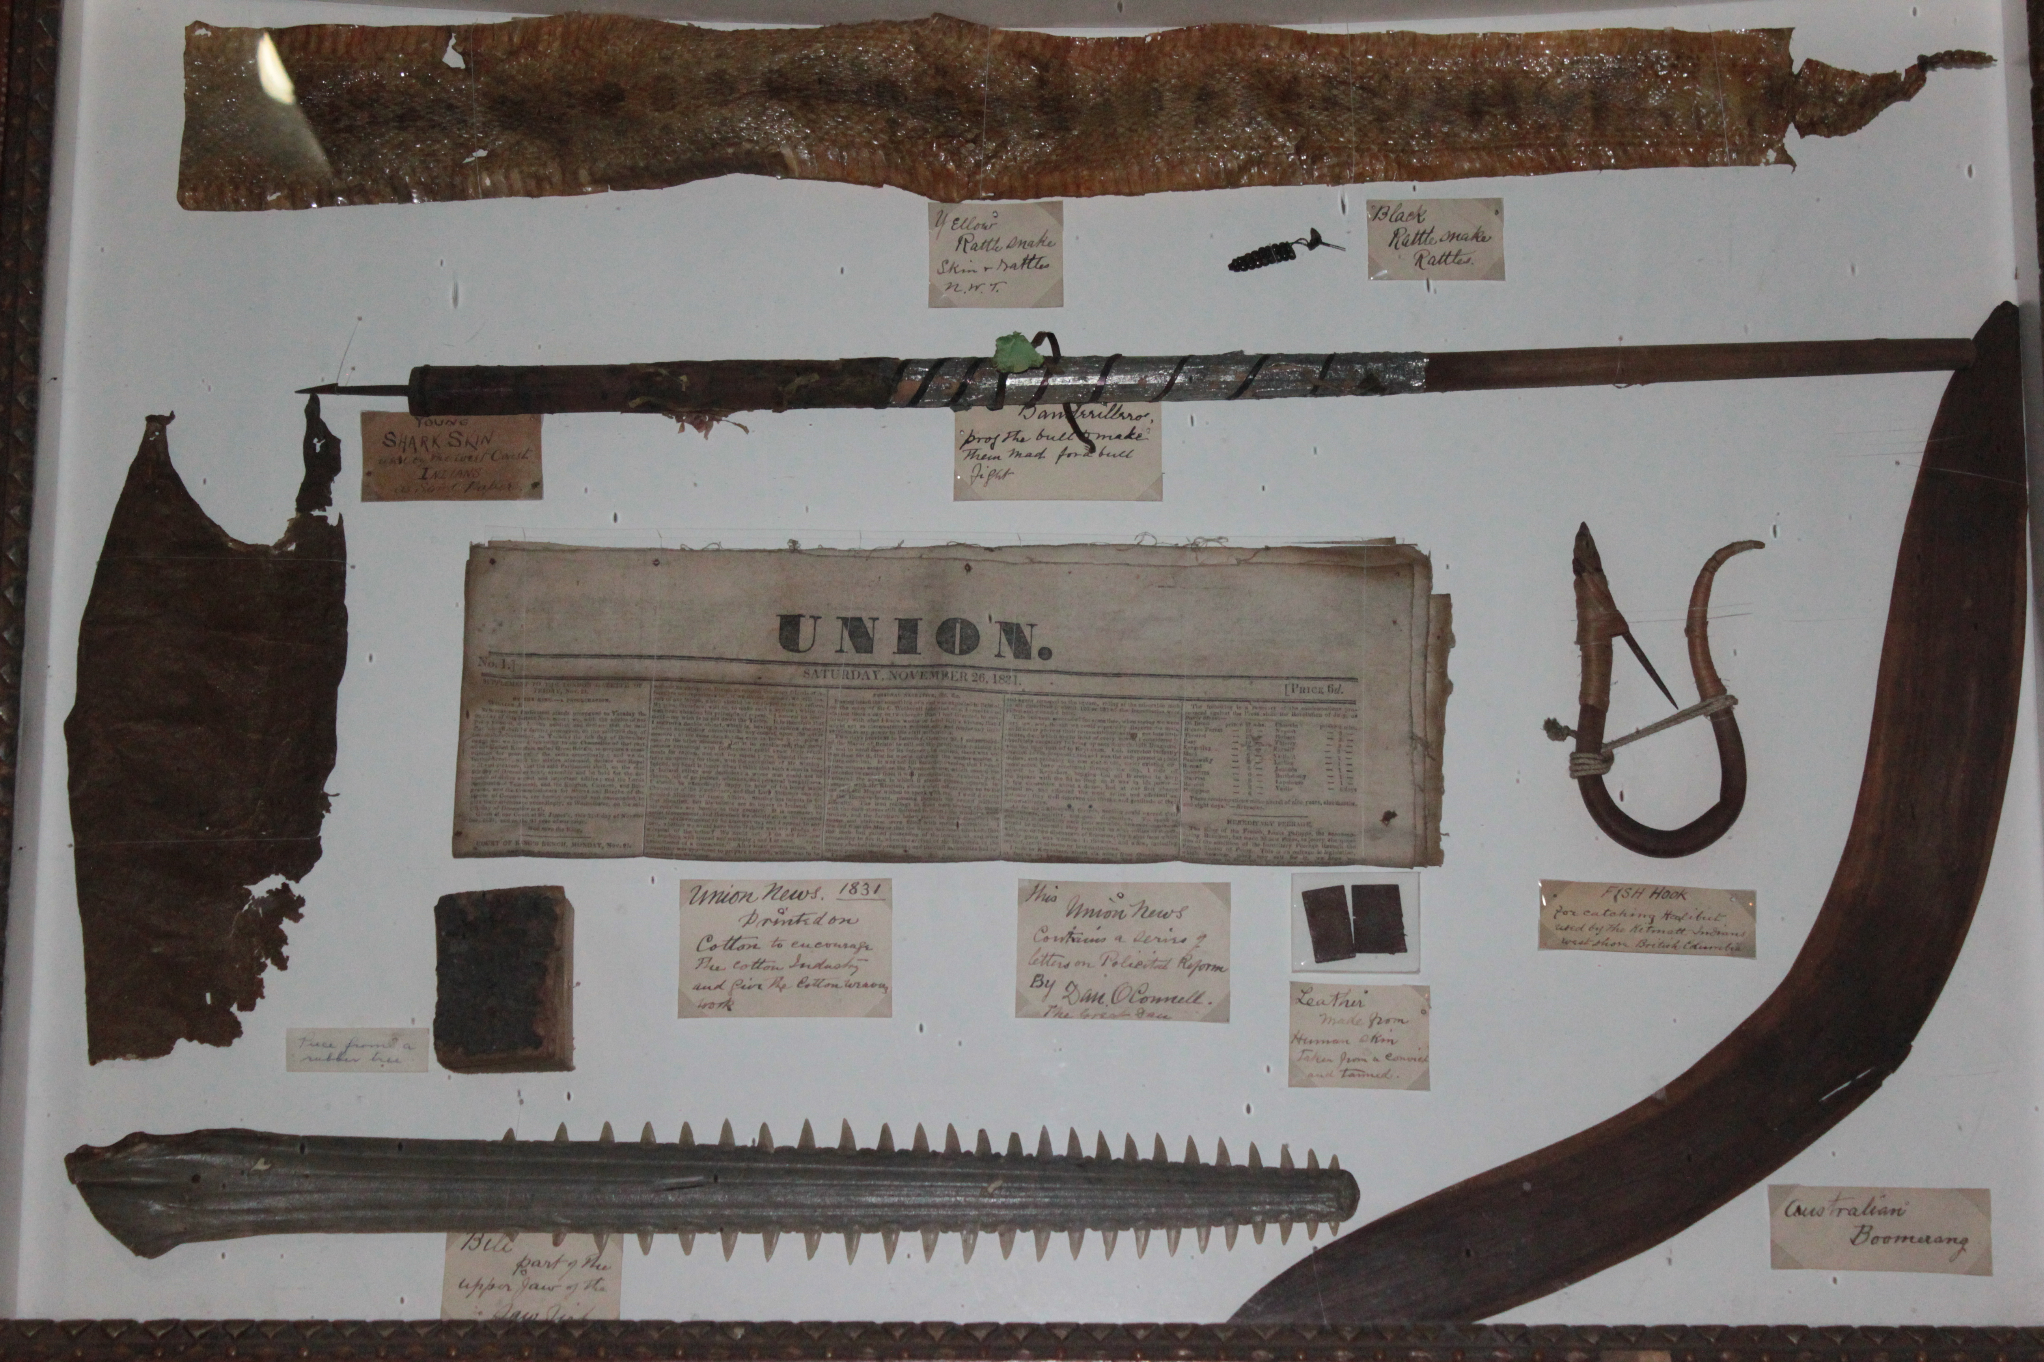
The Inventory project is moving along very well. Since the last newsletter, we have finished cataloguing two more storage areas. Combined, those areas housed a few thousand artifacts, all of which were entered into the museum’s database and placed into their designated areas. We have accomplished this feat through the assistance of our volunteers, who share our commitment to the safe keeping and proper organization of the collection.
Having been through an abundance of artifacts, we have come across some surprising finds and feel it prudent to share a couple of our more interesting discoveries. Hidden behind a shelf of tiny floral teacups and large picture frames, our crew unearthed a rather mysterious shadow box that contained a variety of unexpected oddities. These included preserved shark skin, a yellow rattlesnake rattle, an authentic boomerang from Australia, and the serrated bill of a sawfish. With little documentation on this display, it remains a museum mystery.
Amongst a plethora of ceramic artifacts, we also discovered a beautiful orange, blue and gold floral dish set that had a rather fascinating history. Manufactured by the British company William Brownfield & Son around 1870, these dishes were originally part of a 120 piece set which decorated the banquet tables when Brantford officially became a city in 1877. The plates were later stored in the city vault before being sold to the Gandy Dancers Club - a railroad club - and used until the late 1890s. A portion of the set eventually made its way to the museum. What will we find next?

